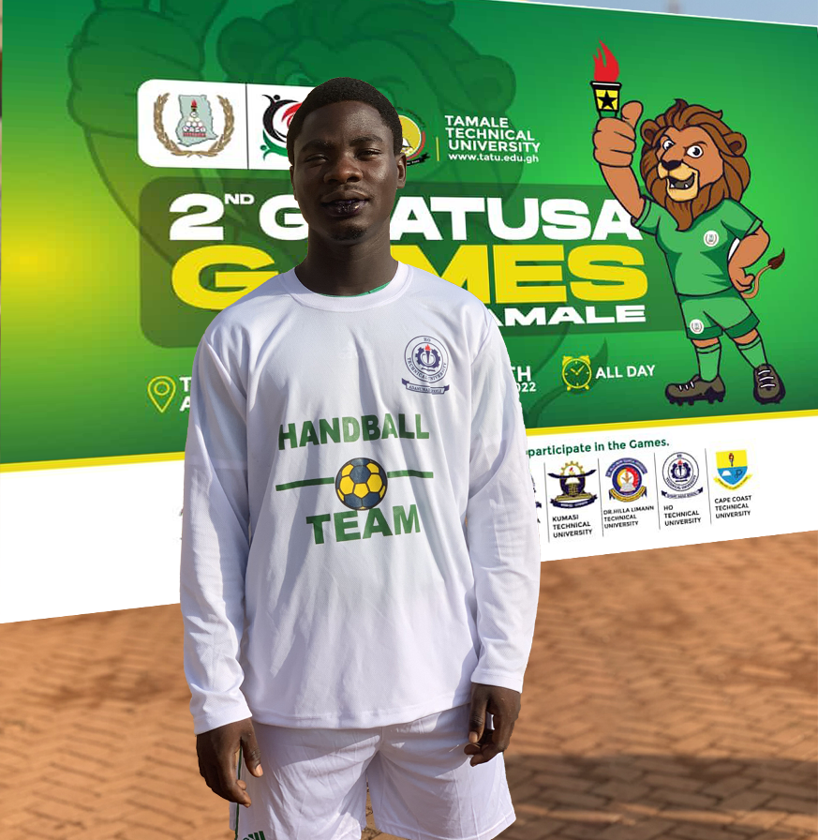
AVORNU SOLOMON
CELL: +233 54 074 4429
EMAIL: avornusolomon6@gmail.com

POSITION: LINE PLAYER/PIVOT
ALTERNATIVE: CENTER BACK, LEFT BACK and RIGHT BACK
DEFENSE 6-0: NUMBER 2, 3, 4 & 5
DATE OF BIRTH: 11.09.2001
HEIGHT: 1.61m
WEIGHT: 67.9kg
NATIONALITY: GHANAIAN
STATUS: Currently playing for
- Ho Technical University Hb Team
- Ho Stars Handball Club

ABILITIES
- Very good in defense
- Good at winning fouls
- Speed
- Physical strength
- Fast feinting
- Powerful shooting technique
- Good finisher (Goal scoring)

CLUB HISTORY
- St Peters RC JHS Handball Team (Somanya, Ghana) 2016-2017
- SONRISE CHRISTIAN HIGH HANDBALL TEAM (Ho, Ghana) 2018-2020

TROPHIES
- 1st place on 46th Annual Volta regional central zone inter-school sports competition 2020
- 3rd place on 2nd GHATUSA GAMES 2022

REFERENCES
- Sonrise Christian High School Handball coach:
Akoto Constant: +233 20 163 1871

- Ho Technical University Handball coach:
Otis Ahose: +233 24 440 5810

