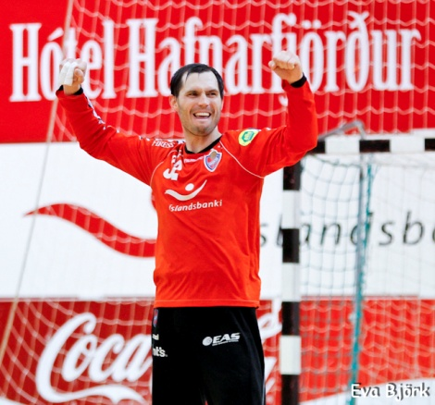
Name: Giedrius Morkūnas
Date of birth: 1987 november 7
Height: 188cm
Waith: 93 kg
Nationality: lithuanian
Position: goalkeeper nr. 32
Now playing at "Haukar" handball club, Iceland
Education: „Vilnius Pedagogical University“ bachelor of physical education
E-mail: giedrius.morkunas@gmail.com

Sports achievement
2014-2015: Selected in to "Team of the year" as a best goalkeeper
MVP player of the year
Iceland champion
Iceland cup- final 4
Best player of the match: Lithuania vs Bosnia and Hercogovina

2013- 2014: EHF Cup 2 round
Icelands Super cup winner
Iceland lygue- Haukar 2nd place, Iceland Cup winner
Nominated in to top 3 best goal keepers in Iceland
Selected to represent Lithuanian national team

2012- 2013: EHF Cup 2 round
Iceland lygue- Haukar 2nd place

2010- 201: The highest Lithuanian man handball lygue- VHC „Šviesa“ 5th place
The Baltic handball lygue- VHC „Šviesa“ 3rd place
Lithuanian student lygue- 1st place
50ty unniversary Lituanian Radio and Television Cup- 2nd place
2009- 2010: The highest Lithuanian man handball lygue- VHC „Šviesa“ 5th place
Lithuanian student handball lygue- 1st place
2008- 2009: The highest Lithuanian man handball lygue- Vilniaus „VPU Šviesa- Savanoris“ 5th place
Lithuanian student handball lygue- 1st place
Selected to represent Lithuanian national team

2007- 2008: The highest Lithuanian man handball lygue- Vilniaus „VPU Šviesa- Savanoris“ 5th place
Lithuanian student handball lygue- 3rd place

2006- 2007: The highest Lithuanian TELE-2 handball lygue- Vilniaus „VPU Šviesa- Savanoris“ 7th place
The Baltic handball lygue- Vilniaus „VPU Šviesa- Savanoris“ 10th place
XXIII SELL students games- Vilniaus „VPU Šviesa- Savanoris“ 3rd place

2005- 2006: Lithuanian junior handball championship- KKSC „Utena“ 1st place
Selected to represent Lithuanian junior National team
The Baltic handball lygue- Vilniaus „VPU Šviesa- Savanoris“ 7th place

2004- 2005: Lithuanian junior handball champioship- KKSC „Utena“ 1st place
Represented Lithuanian junior National team in Sweden, grup E

