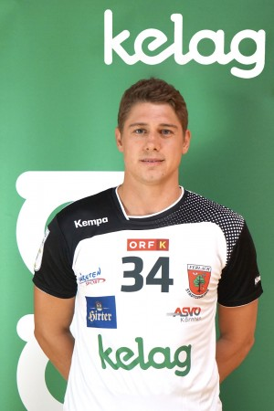
Anže Ratajec

Date of birth: 04. 03. 1991

Nationality: Slovenian

Height: 188 cm

Weight: 92 kg

Position offence: Middle back / Left back

Position defence: Central

Current club: Sc Ferlach

Previous Clubs: RK Trimo Trebnje, KK Csurgoi, RK Gorenje Velenje

Contract with Club expires: 31. 5. 2019

Specialities:
- Playmaker
- Good in defence.
- Working with line player.
- Leader and motivator.
- Hard worker

This season average: 18 games, 85 goals/average 4,72

