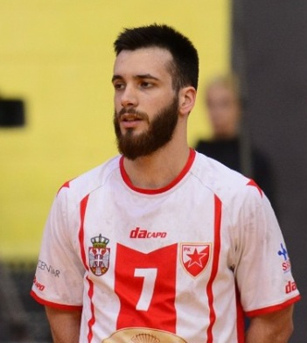
NIKOLA NIKOLIĆ No.7

- Date of birth: 09.06.1993
- Position: LEFT WING
- Height: 180cm
- Weight: 75kg
- Nationality: SERBIAN
- Current Club: HC RED STAR

Club History

2009-2017 HC NOVI BEOGRAD (SERBIA)
2017-2018 HC POŽAREVAC (SERBIA)
2018- HC RED STAR (SERBIA)

Biography

Nikola Nikolić (born 9 June 1993 in Belgrade) is a Serbian handball player who plays for HC Red star in Serbian superleague.

Strenghts and Skills

reflexes–concentration–jumping–speed–strenght-acceleration-decisive–teamworker-hight work rate-great stamina-well anticipation on the game-quick counter attack

One of the fastest left wings in Serbia.
Strong in defence.

Video
https://youtu.be/q41ZgauspwI

Contact:

Mob. +381645907001
Facebook Page: https://m.facebook.com/brkati7d
E-mail: brkati7d@gmail.com
Online CV: https://sportcontact.me/profile/nikola-nikolic/

